**Title: Healthify**

Healthify is an Indian digital health and wellness company, which provides an app with services such as calorie tracking and advice on nutrition and fitness. It is available on the Android and iOS platforms, and can be used with wearable technology such as activity trackers.

**Problem Definition :**

Healthify is a application of a particular hospital through which a user can buy medicine , book for a lab test and book for a doctor’s appointment. It allows easy for patients to book for an appointment with specified date and time so that the patient don’t need to wait for log time in hospital for doctor consultation.

**Objective :**

People of any age can be health-conscious, but the majority of your audience will be in the 18-34 category. They are generally educated. Health-conscious individuals have done their research and know what they believe about good health. They are skeptical of sensational messaging.

**Database Design:**

This project has MySQL database for storage of register and login details of the users and also it has some more tables to store doctor’s appointment details, buy medicine details and lab test booking details.

**User Interface Design (screenshots):**

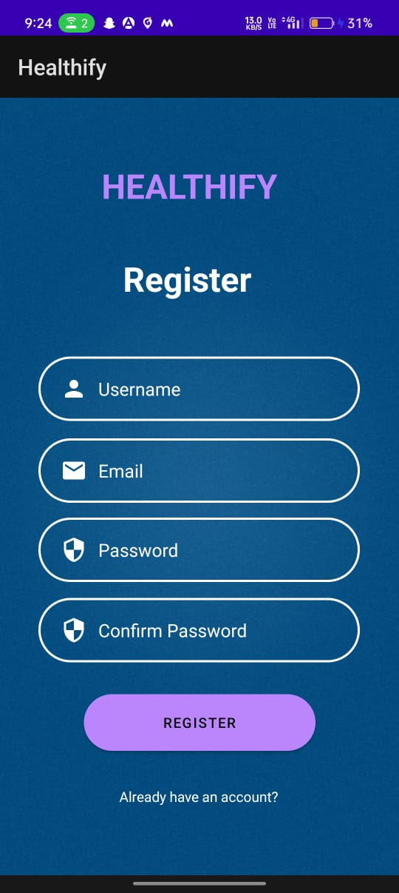  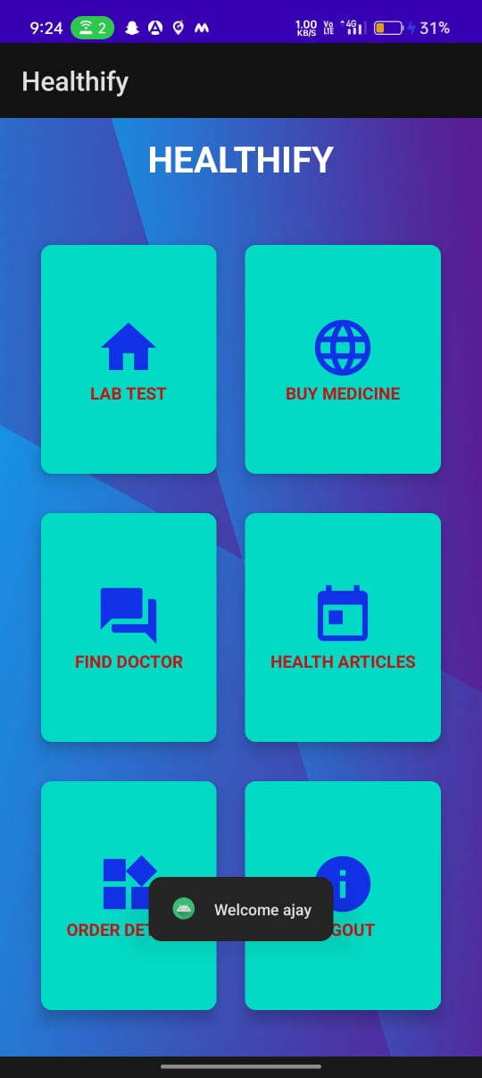

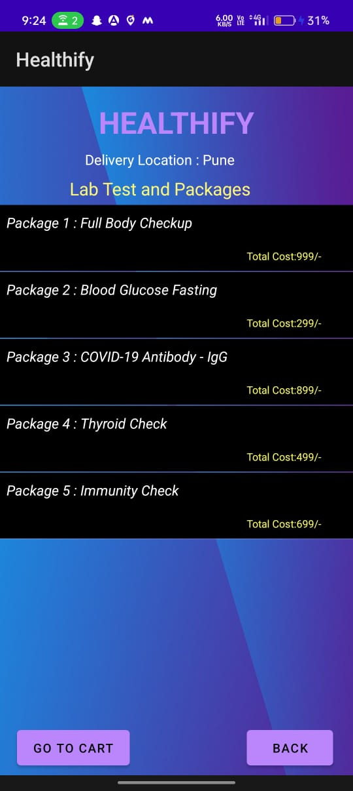 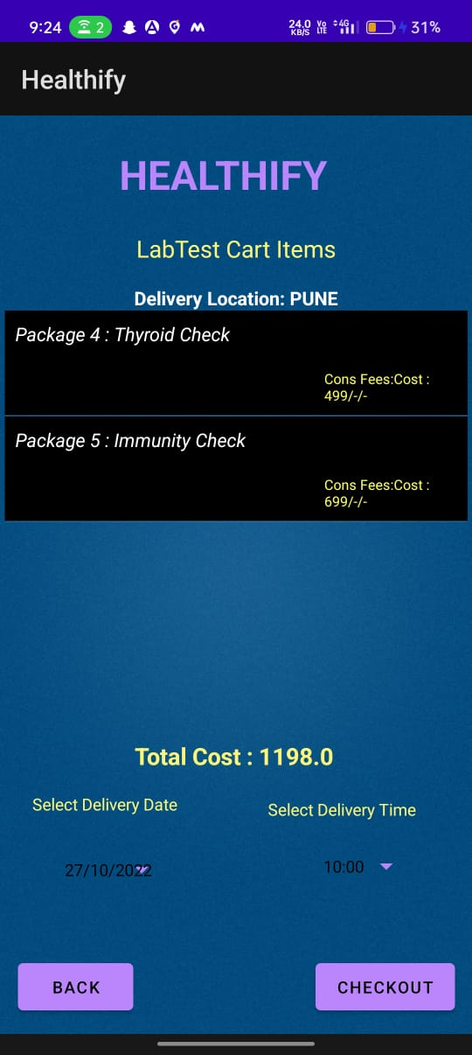 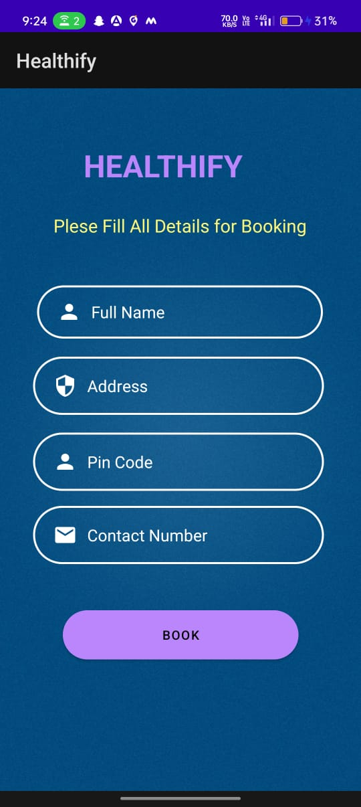

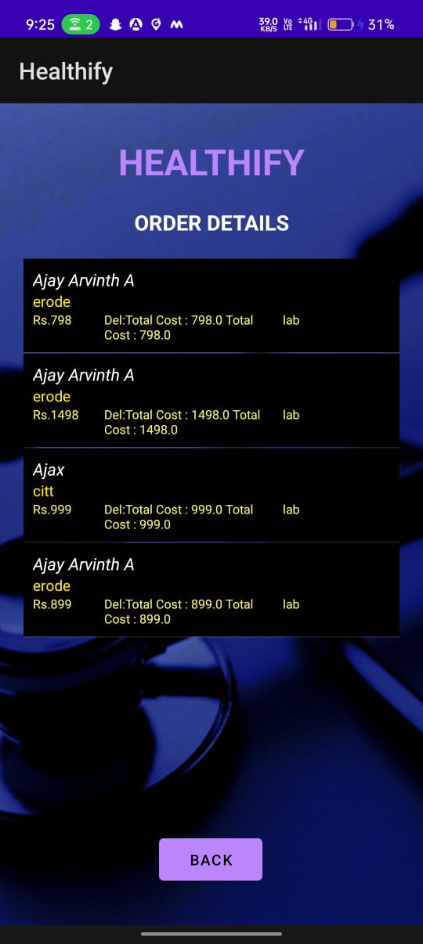 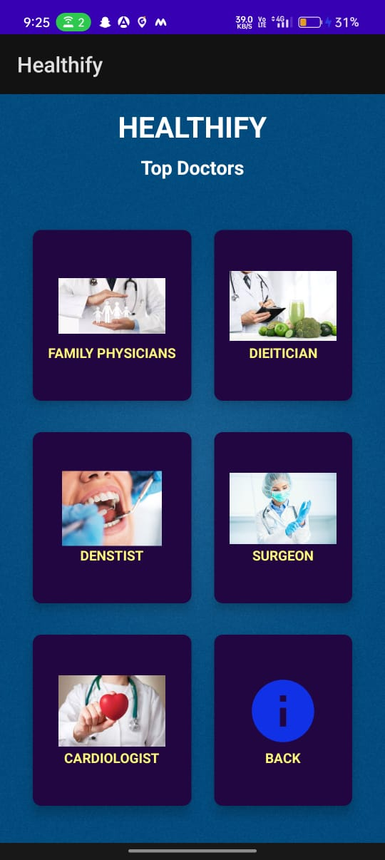 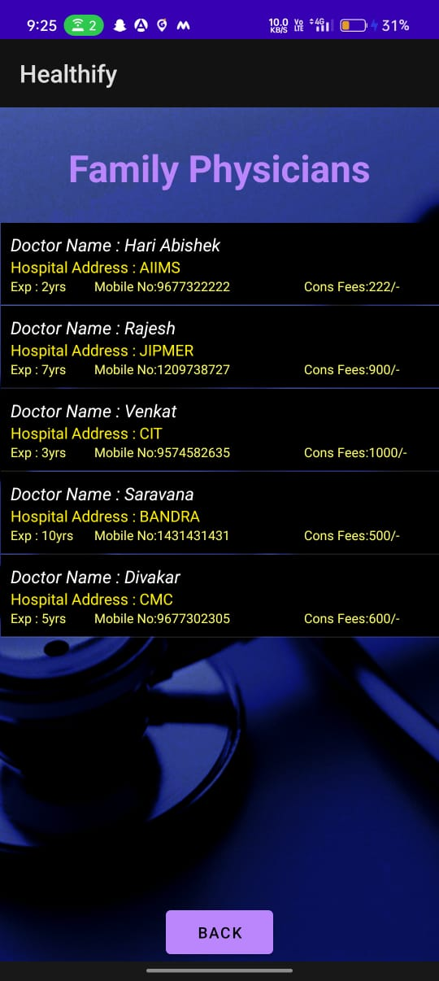

**Conclusion:**

As we hustle in the world of hybrid working and resetting our work-life balance, there is a ton that we must consider as our priorities. While the concept is becoming exceptionally popular among the corporate crowd, we need to take a minute to understand that, in the long run, earning a healthy lifestyle is equally important. The foundation of Healthify speaks truly to the idea of convenient and personalized health guidance.

The paradigm shift in the health and fitness market has made a significant mark in digital fitness. Thus, taking a giant leap toward digital fitness, Healthify is committed to transforming a billion lives and contributing to global wellness.